Quaid-i-Azam University
Students Clearance Process
NOTE: Before initiating the clearance process, all students(Except Seizure & Cancellation Cases) are required to fill/submit Online Alumni Membership Form available at (http://alumni.qau.edu.pk/) and attach its copy with this clearance form otherwise clearance will not be issued.
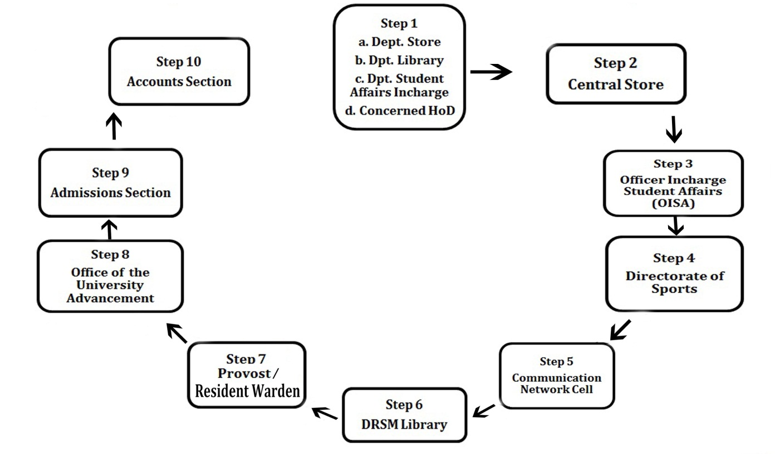

Step 1: Departmental Store+ Departmental Library+ Departmental Student Affairs Incharge then from Concerned Head of the Department
Step 2: Central Store (QAU Central Workshop) Near Social Huts (Ext: 3092)
Step 3: Officer Incharge Student Affairs (OISA) (School of Economics, Room No. 46) (Ext: 3028)
Step 4: Directorate of Sports (Department of Mathematics) (Ext: 2173)
Step 5: Communication Network Cell (Computer Centre, Room No. 27) (Ext:2181)
Step 6: Dr. Raziuddin Siddiqi Memorial (DRSM) Library (Ext: 2071)
Step 7: Office of the Provost/Resident Warden (Girls/Boys Hostels) Hostel Office
Step 8: Office of the University Advancement (New Admin Block, Room No. 62)(Ext: 4061)
Step 9: Admission Section (New Admin Block, Room No. 15 & 19) (Ext: 4065)
Step 10: Final Submission in the Accounts Section (New Admin Block, Room No. 29) (Ext: 4092)
- Please dial (051) 9064 before the desired extension
Quaid-i-Azam University
Dr. Raziuddin Siddiqi Memorial Library

Dated: _____________________ Session: _____________________

SUBJECT: LIBRARY CLEARANCE CERTIFICATE.

Certified that Mr. /Miss/Mrs. /Dr. ______________________________________________________________________________________________________
Student of BS/MSc/MS/MPhil/PhD from the Department/School/Centre/Institute of ______________________________________________________________________________________________________
whose Signature appears below; has returned all the material borrowed by him/her from the DRSM Library.
Specimen Signature of the Student: __________________________________________________
Cleared by:
- Seminar/ Departmental Library: _________________________________________________

- Photostat (Ground Floor): _________________________________________________

- Circulation Section (2nd Floor)*: __________________________________________________

- Fine: (If any)* _________________________________________________

* Provision of Student Membership Card is mandatory for clearance. In case of non-availability, deposit Rs. 50/- in QAU Account at HBL/Askari Bank Ltd. QAU Branch, Islamabad.

Librarian
DRSM Library

Student Clearance Form (Copy for Admission Section)
For Student’s Use
Department: |  |  |  |  |  | Programme:
Semester: |  | Session: |  |  |  | Registration No:
Student’s Name:
Home Address:
Contact Tel: |  | Mobile: |  |  |  | E-mail:
Reason for Clearance: | Completion |  | _____________ | Seizure | _____________ |  | Cancellation | _____________
Note to the Student
Upon completion of their academic programme, students must obtain a signature from above mentioned departments for clearing of all the obligations in University in order to clear their record, it is necessary to process this clearance form. It is the responsibility of the student to check with the QAU Departments listed below and obtain a final clearance before leaving Quaid-i-Azam University. REGISTRAR

For Official Use Only
Concerned Institute/School/Department of the Student
Head of the Department/Chairperson | Stamp & Signature | Date: / /
Departmental Student Affairs Incharge | Stamp & Signature | Date: / /
Store Section (Incharge):
Departmental Store Section (Incharge) | Stamp & Signature | Date: / /
Central Store Section (Incharge) | Stamp & Signature | Date: / /
Library Section (Librarian DRSM): It is confirmed that the student has no obligations regarding borrowing books and other library resources.
Name: | Stamp & Signature | Date: / /
Officer Incharge Student Affairs (OISA): It is confirmed that nothing is pending against the mentioned student.
Name: | Stamp & Signature | Date: / /
Office of the University Advancement (Manager University Advancement): It is confirmed that the student has filled Online Alumni Membership Form and submitted its hard copy to the Manager University Advancement.
Name: | Stamp & Signature | Date: / /
Manager Financial Assistance  (In case of Seizure/ Cancellation only) | Stamp & Signature | Date: / /
Incharge Communication Network Cell (CNC): It is confirmed that the mentioned student has handed over his/her email password.
Name: | Stamp & Signature | Date: / /
Directorate of Sports (Director Sports): It is confirmed that nothing is pending against the mentioned student.
Name: | Stamp & Signature : | Date: / /
Admission Section (AR Admissions): It is confirmed that the mentioned student has submitted his/her complete documents i.e. (Original NOC from institution last attended and attested copies of last DMC & Degree)
Name: | Stamp & Signature | Date: / /
Accounts/Finance Section (Accounts Officer): It is confirmed that all the financial settlement have been completed.
Name: | Stamp & Signature | Date: / /
Student Pledge: It is confirmed that I have received all the official/original documents (transcript & Certificates) from QAU.
Name: | Signature | Date: / /
Student Clearance Form (Copy for Accounts Section)
For Student’s Use
Department: |  |  |  |  |  | Programme:
Semester: |  | Session: |  |  |  | Registration No:
Student’s Name:
Home Address:
Contact Tel: |  | Mobile: |  |  |  | E-mail:
Reason for Clearance: | Completion |  | _____________ | Seizure | _____________ |  | Cancellation | _____________
Note to the Student
Upon completion of their academic programme, students must obtain a signature from above mentioned departments for clearing of all the obligations in University in order to clear their record, it is necessary to process this clearance form. It is the responsibility of the student to check with the QAU Departments listed below and obtain a final clearance before leaving Quaid-i-Azam University. REGISTRAR

For Official Use Only
Concerned Institute/School/Department of the Student
Head of the Department/Chairperson | Stamp & Signature | Date: / /
Departmental Student Affairs Incharge | Stamp & Signature | Date: / /
Store Section (Incharge):
Departmental Store Section (Incharge) | Stamp & Signature | Date: / /
Central Store Section (Incharge) | Stamp & Signature | Date: / /
Library Section (Librarian DRSM): It is confirmed that the student has no obligations regarding borrowing books and other library resources.
Name: | Stamp & Signature | Date: / /
Officer Incharge Student Affairs (OISA): It is confirmed that nothing is pending against the mentioned student.
Name: | Stamp & Signature | Date: / /
Office of the University Advancement (Manager University Advancement): It is confirmed that the student has filled Online Alumni Membership Form and submitted its hard copy to the Manager University Advancement.
Name: | Stamp & Signature | Date: / /
Manager Financial Assistance  (In case of Seizure/ Cancellation only) | Stamp & Signature | Date: / /
Incharge Communication Network Cell (CNC): It is confirmed that the mentioned student has handed over his/her email password.
Name: | Stamp & Signature | Date: / /
Directorate of Sports (Director Sports): It is confirmed that nothing is pending against the mentioned student.
Name: | Stamp & Signature : | Date: / /
Admission Section (AR Admissions): It is confirmed that the mentioned student has submitted his/her complete documents i.e. (Original NOC from institution last attended and attested copies of last DMC & Degree)
Name: | Stamp & Signature | Date: / /
Accounts/Finance Section (Accounts Officer): It is confirmed that all the financial settlement have been completed.
Name: | Stamp & Signature | Date: / /
Student Pledge: It is confirmed that I have received all the official/original documents (transcript & Certificates) from QAU.
Name: | Signature | Date: / /
Student Clearance Form (Copy for Examination Section)
For Student’s Use
Department: |  |  |  |  |  | Programme:
Semester: |  | Session: |  |  |  | Registration No:
Student’s Name:
Home Address:
Contact Tel: |  | Mobile: |  |  |  | E-mail:
Reason for Clearance: | Completion |  | _____________ | Seizure | _____________ |  | Cancellation | _____________
Note to the Student
Upon completion of their academic programme, students must obtain a signature from above mentioned departments for clearing of all the obligations in University in order to clear their record, it is necessary to process this clearance form. It is the responsibility of the student to check with the QAU Departments listed below and obtain a final clearance before leaving Quaid-i-Azam University. REGISTRAR

For Official Use Only
Concerned Institute/School/Department of the Student
Head of the Department/Chairperson | Stamp & Signature | Date: / /
Departmental Student Affairs Incharge | Stamp & Signature | Date: / /
Store Section (Incharge):
Departmental Store Section (Incharge) | Stamp & Signature | Date: / /
Central Store Section (Incharge) | Stamp & Signature | Date: / /
Library Section (Librarian DRSM): It is confirmed that the student has no obligations regarding borrowing books and other library resources.
Name: | Stamp & Signature | Date: / /
Officer Incharge Student Affairs (OISA): It is confirmed that nothing is pending against the mentioned student.
Name: | Stamp & Signature | Date: / /
Office of the University Advancement (Manager University Advancement): It is confirmed that the student has filled Online Alumni Membership Form and submitted its hard copy to the Manager University Advancement.
Name: | Stamp & Signature | Date: / /
Manager Financial Assistance  (In case of Seizure/ Cancellation only) | Stamp & Signature | Date: / /
Incharge Communication Network Cell (CNC): It is confirmed that the mentioned student has handed over his/her email password.
Name: | Stamp & Signature | Date: / /
Directorate of Sports (Director Sports): It is confirmed that nothing is pending against the mentioned student.
Name: | Stamp & Signature : | Date: / /
Admission Section (AR Admissions): It is confirmed that the mentioned student has submitted his/her complete documents i.e. (Original NOC from institution last attended and attested copies of last DMC & Degree)
Name: | Stamp & Signature | Date: / /
Accounts/Finance Section (Accounts Officer): It is confirmed that all the financial settlement have been completed.
Name: | Stamp & Signature | Date: / /
Student Pledge: It is confirmed that I have received all the official/original documents (transcript & Certificates) from QAU.
Name: | Signature | Date: / /
Student Clearance Form (Student’s Copy)
For Student’s Use
Department: |  |  |  |  |  | Programme:
Semester: |  | Session: |  |  |  | Registration No:
Student’s Name:
Home Address:
Contact Tel: |  | Mobile: |  |  |  | E-mail:
Reason for Clearance: | Completion |  | _____________ | Seizure | _____________ |  | Cancellation | _____________
Note to the Student
Upon completion of their academic programme, students must obtain a signature from above mentioned departments for clearing of all the obligations in University in order to clear their record, it is necessary to process this clearance form. It is the responsibility of the student to check with the QAU Departments listed below and obtain a final clearance before leaving Quaid-i-Azam University. REGISTRAR

For Official Use Only
Concerned Institute/School/Department of the Student
Head of the Department/Chairperson | Stamp & Signature | Date: / /
Departmental Student Affairs Incharge | Stamp & Signature | Date: / /
Store Section (Incharge):
Departmental Store Section (Incharge) | Stamp & Signature | Date: / /
Central Store Section (Incharge) | Stamp & Signature | Date: / /
Library Section (Librarian DRSM): It is confirmed that the student has no obligations regarding borrowing books and other library resources.
Name: | Stamp & Signature | Date: / /
Officer Incharge Student Affairs (OISA): It is confirmed that nothing is pending against the mentioned student.
Name: | Stamp & Signature | Date: / /
Office of the University Advancement (Manager University Advancement): It is confirmed that the student has filled Online Alumni Membership Form and submitted its hard copy to the Manager University Advancement.
Name: | Stamp & Signature | Date: / /
Manager Financial Assistance  (In case of Seizure/ Cancellation only) | Stamp & Signature | Date: / /
Incharge Communication Network Cell (CNC): It is confirmed that the mentioned student has handed over his/her email password.
Name: | Stamp & Signature | Date: / /
Directorate of Sports (Director Sports): It is confirmed that nothing is pending against the mentioned student.
Name: | Stamp & Signature : | Date: / /
Admission Section (AR Admissions): It is confirmed that the mentioned student has submitted his/her complete documents i.e. (Original NOC from institution last attended and attested copies of last DMC & Degree)
Name: | Stamp & Signature | Date: / /
Accounts/Finance Section (Accounts Officer): It is confirmed that all the financial settlement have been completed.
Name: | Stamp & Signature | Date: / /
Student Pledge: It is confirmed that I have received all the official/original documents (transcript & Certificates) from QAU.
Name: | Signature | Date: / /

The Deputy Treasurer,
Quaid-i-Azam University,
Islamabad.

SUBJECT: REFUND OF SECURITIES

Dear Sir,
It is stated that I have passed my BS/MSc/MBA/MPA/MS/MPhil/PhD final examination from the Department/School/Centre/Institute of ____________________________ Quaid-i-Azam University, Islamabad.
It is therefore requested that my securities may kindly be refunded. Clearance Form in this regard is attached for your kind consideration.

Yours Obediently,
Student’s Name: ______________________________
Address: _______________________________________
_______________________________________
_______________________________________
Signature: ______________________________
Dated: ______________________________

Head of Department

The Controller of Examinations,
Quaid-i-Azam University,
Islamabad.

SUBJECT: ISSUANCE OF DMC

Dear Sir,
It is stated that I have passed my BS/MSc/MBA/MPA/MS/MPhil/PhD final examination from the Department/School /Centre/Institute of ____________________________ Quaid-i-Azam University, Islamabad.
It is, therefore, requested that my DMC may kindly be issued and oblige.

Yours Obediently,
Student’s Name: ______________________________
Address: _______________________________________
_______________________________________
_______________________________________
Signature: ______________________________
Dated: ______________________________

Head of Department

QUAID-I-AZAM UNIVERSITY
APPLICATION FOR ISSUANCE OF
DEGREE/DIPLOMA/CERTIFICATE

The Controller of Examinations,
Quaid-i-Azam University,
Islamabad.
1. Student’s Name : ________________________________________________
2. Father’s Name : ________________________________________________
3. University Registration No. : ________________________________________________
4. Degree/Diploma/Certificate : ________________________________________________
5. Faculty : ________________________________________________
6. PM&DC Registration No : ________________________________________________
(For Medical Students Only)
7. Habib Bank Ltd. / Askari Bank Ltd. QAU Branch Deposit Slip No: ______________________
Dated: _______________ for Rs. ____________ (Please attach original receipt)
8. Mode of Delivery
A. By Hand B. Through Mail
9. Mailing Address : ________________________________________________
________________________________________________
10. Contact Numbers : Tel: _____________________Mobile: _____________________
11. Recommendation by the : ________________________________________________
Chairperson/Dean/Director : ________________________________________________
of respective Department/ Institute/Centre

Y | N
Y | N
Y | N
Y | N
Y | N
12. Please ensure the following before submitting Application:
- Have you attached two attested copies of your last degree?
- Have you attached two copies of transcript/DMC of existing programme?
- Have you attached the deposit slip of degree/diploma/certificate fee?
- Have you attached the clearance certificate, issued by Admission Section?
- Have you attached an attested copy of your CNIC?

Dated: _______________ Applicant’s Signature: ___________________________________________________
 |  |  |  |  | - |  |  |  |  |  |  |  | -
CNIC No:

Quaid-i-Azam University
(Office of the Resident Warden)

No. QAU/BH/GH/Clearance/20 - Dated: / /

Note: (To be filled in and got completed by the applicant)
APPLICATION FOR FINAL CLEARANCE (NON BOARDER)
I Mr./Miss ______________________________________________ S/D/O___________________________________________
Class _________________________ Department of ___________________________________________________solemnly declare that I had not been resident of Boys Hostels during my whole academic session/period in the University i.e. from _______________ to _________________ Thus; I may Please be issued Hostel’s Clearance Certificate.
Signature of Applicant
_______________________________________________________________________________________________________________
Subject: FINAL CLEARANCE FROM BOYS/GIRLS HOSTEL FOR (NON-BOARDER)
Certified that Mr./Miss ________________________________________S/D/O ____________________________________
Class ___________________________ Department of ________________________________________has never availed hostel’s facility during above- motioned period, as per hostel allotment /dues record. He may please be issued final clearance from hostel as non-boarder.
Dues Clerk
Resident Warden
_______________________________________________________________________________________________________________
Quaid-i-Azam University
(Office of the Resident Warden)

No. QAU /BH/GH/Clearance/20 -
Subject: FINAL CLEARANCE FROM BOYS/GIRLS HOSTEL FOR (NON BOARDER)
Certified that Mr. /Miss ______________________________________________ S/D/O______________________________
Class ______________________ Department of _____________________________________________has never availed
Hostel’s facility during his whole academic period, as per hostel’s allotment/dues record.

Dues Clerk
Resident Warden

